July 11, 2014
VIA ELECTRONIC MAIL

Charles Carley
Township Engineer
Piscataway Township
555 Sidney Road
Piscataway, NJ 08854

Re: Piscataway - RLC system certification – All intersections

Mr. Carley:
Attached please find copies of ATS’ system diagnostic reports which are preventive maintenance logs for certifying system functionality during the specific time period. These reports can be attached to your certification validating that the red light camera systems at the referenced intersections in Piscataway were functioning properly for the noted periods on each report.
Sincerely,
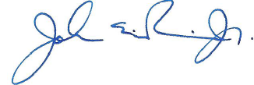
John E. Rein, Jr.
Senior Account Manager
North East Region (NJ-NY)

Cc: Lieutenant S. Iannuzzo

